APPENDIX

APPENDIX 1: THE ORGANIZATION OF
VIETNAMESE PEOPLE’S ARMY

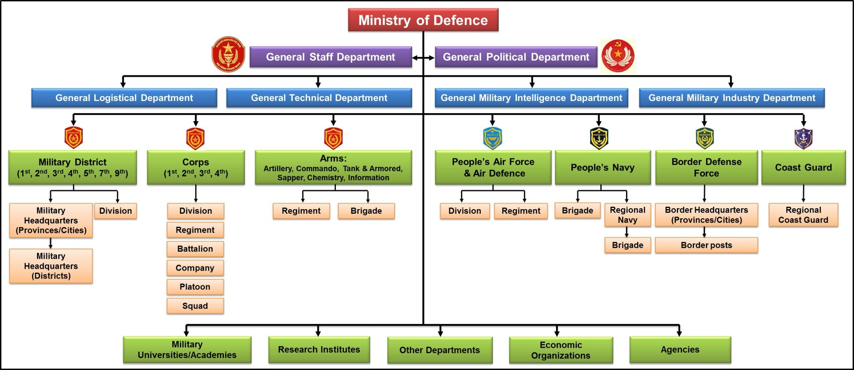

APPENDIX 2: RANKS OF THE VIETNAMESE PEOPLE’S ARMY
Tier | Level | Army | Air- defense aviation | Navy | Border | Coast Guard
Officers of General | General | 
Officers of General | Senior Lieutenant General /Admiral |  |  | 
Officers of General | Lieutenant General /Vice Admiral |  |  |  |  | 
Officers of General | Major General /  Rear Admiral |  |  |  |  | 
Officers of Major | Colonel |  |  |  |  | 
Officers of Major | Senior Lieutenant Colonel |  |  |  |  | 
Officers of Major | Lieutenant Colonel |  |  |  |  | 
Officers of Major | Major |  |  |  |  | 
Officers of lieutenant | Captain |  |  |  |  | 
Officers of lieutenant | Senior Lieutenant |  |  |  |  | 
Officers of lieutenant | Lieutenant |  |  |  |  | 
Officers of lieutenant | Second Lieutenant |  |  |  |  | 
Officer Cadet | Officer Cadet |  |  |  | 
Non - Commissioned Officer | Sergeant Major |  |  |  |  | 
Non - Commissioned Officer | Sergeant |  |  |  |  | 
Non - Commissioned Officer | Corporal |  |  |  |  | 
Soldier | Private First Class |  |  |  |  | 
Soldier | Private |  |  |  |  | 

Commissioned officer ranks

The rank insignia of Coast guard officers.
Rank group | General/  Flag officers |  | Senior officers
VCG |  |  |  |  |  |  |  |  |  | 
 |  | Lt  Genaral | Major Genaral | Colonel |  | Senior Colonel |  | Lt  Colonel |  | Major
 |  | Junior officers |  |  |  |  |  |  | Officer cadet
 |  |  |  |  |  |  |  |  | 
 |  | Captaint | Senior Lieutenant |  | Lieutenant |  | Sub Lieutenant |  | Student Officer

Other ranks
The rank insignia of non-commissioned officers and enlisted personnel.

Rank group | Senior NCOs |  |  |  |  | Junior NCOs |  | Enlisted
VCG
 |  | Thượng sĩ |  | Trung sĩ |  | Hạ sĩ |  | Binh nhất | Binh nhì

SERVICE BRANCHES

The Vietnamese People's Army is subdivided into the following service branches:

-  Vietnam People's Ground Force
-  Vietnam People's Air Force
-  Vietnam People's Navy
-  Vietnam Border Guard
-  Vietnam Coast Guard
-  Cyberspace Operations
- President Ho Chi Minh Mausoleum Defense Force

APPENDIX 3: VIENNAMESEMILITARY UNIFORMS

A. No. 1 - uniforms celebration

1. Male officers, Warrant officer

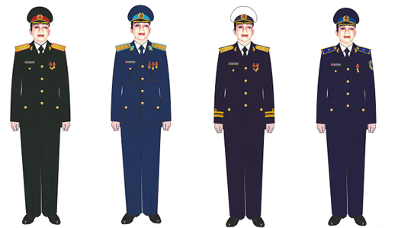
Army |  | Air Defend  Air Force | Navy |  | Coast Guard

2. Female officers, Warrant officer

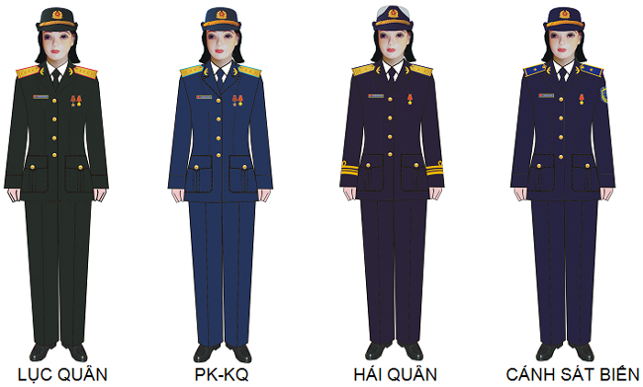
Army |  | Air Defend  Air Force |  | Navy |  | Coast Guard

Where to use:
- Provision of celebration: Date of the Communist Party of Vietnam 03/2; victory 30/4; National Day of the Socialist Republic of Vietnam 02/9; founding of the People's Army Vietnam 22/12.
- To wear in the National Day 02/9; founding of the People's Army Vietnam 22/12. - Honorary Team Captain in a reception unit, military flag officers in the group.

B. Number 2 - Winter Holidays uniform state

1. Male officers, Warrant officer
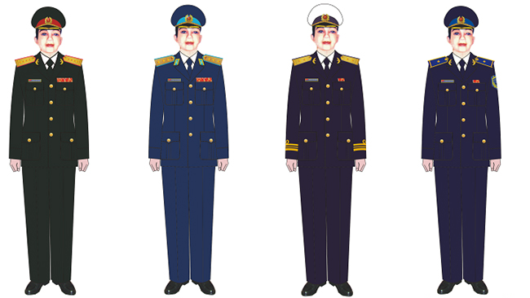
Army |  | Air Defend  Air Force |  | Navy |  | Coast Guard

2. Female officers, Warrant officer

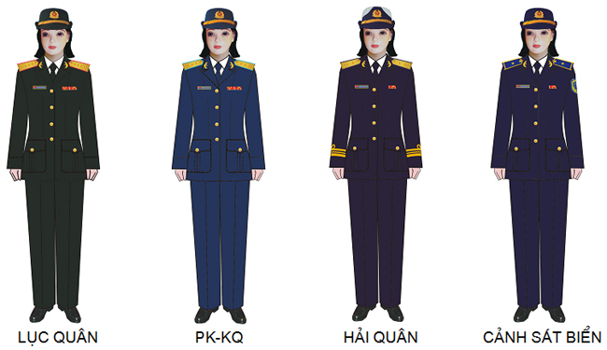
Army |  | Air Defend  Air Force |  | Navy |  | Coast Guard
Where to use:
a) Even in cold weather:
- Provision of holidays by the State, Ministry of Defence, local and organizational units outside the prescribed ceremony celebration dress.
- Technical meeting to announce, Congress Party, Congress of mass organizations in the organizational unit.
- Members of the delegation of the Party, State, Army official visit to the country.
- Business travel and study abroad. Defense Attaché abroad attended the ceremony as the host country.
- To wear in the Lunar New Year.
b) Although both hot and cold seasons:
- During the welcoming ceremony, followed, and delegates to international practice, the leaders of the Party and State ceremonial Army (worn as prescribed by the organizers).
- Delegates to the Party Congress and military, provincial Party Congress, Central cities and national party congress; attend the opening and closing sessions of the National Assembly.
- Serving the trial jury, prosecutor, court clerk at (not worn stem Medal, Medals, Badges).
- Radio and television.
- Member of the Board of the funeral, the funeral organizing committee, the delegation members visited the state funeral, the funeral of the State; and led officers on duty in the funeral visit for officials from Major level or higher.

C. Number 3 - State uniforms summer holidays

1. Male officers, Warrant officer
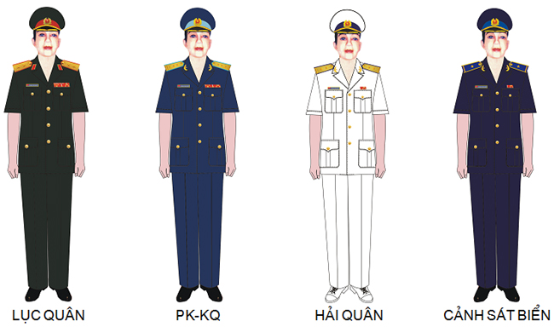
Army |  | Air Defend  Air Force |  | Navy |  | Coast Guard

2. Female officers, Warrant officer
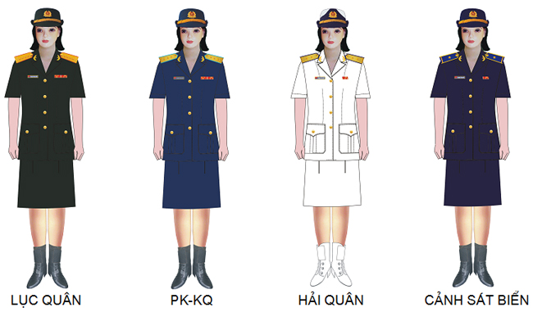
Army |  | Air Defend  Air Force |  | Navy |  | Coast Guard
Where to use:
- During the welcoming ceremony, followed, and delegates to international practice, the leaders of the Party and State ceremonial Army (worn as prescribed by the organizers).
- Members of the delegation of the Party, State, Army official visit to the country.
- Business travel and study abroad. Defense Attaché abroad attended the ceremony as the host country.
- To attend the ceremony due to organizational units.
- Technical meeting to announce, Congress Party, Congress of mass organizations by organizational unit.
- To wear in the Victory Day, 30/4.

D. Number 4 - Usual winter uniform

1. Male officers, Warrant officer
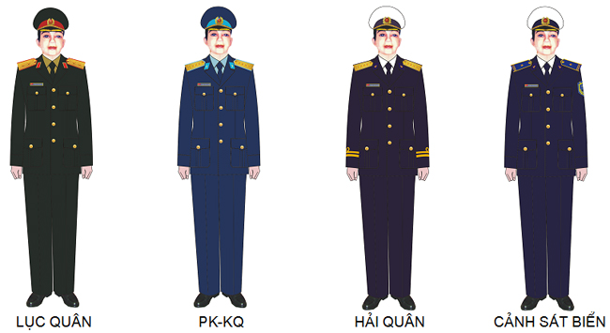
Army |  | Air Defend  Air Force |  | Navy |  | Coast Guard

2. Female officers, Warrant officer
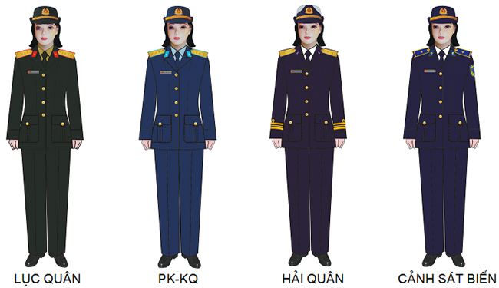
Army |  | Air Defend  Air Force |  | Navy |  | Coast Guard

Where to use: In studying, working, living, daily work.

E. Number 5 - Usual summer uniform

1. Male officers, Warrant officer
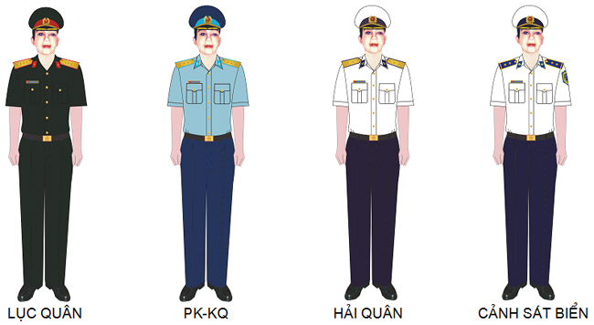
Army |  | Air Defend  Air Force |  | Navy |  | Coast Guard

2. Female officers, Warrant officer
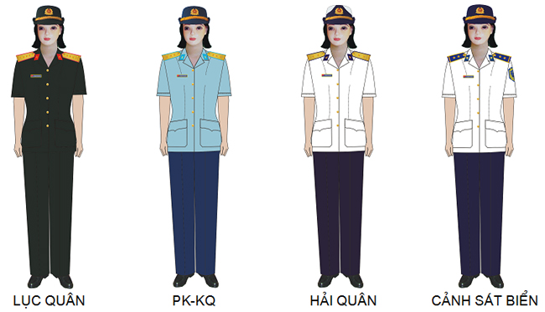
Army |  | Air Defend  Air Force |  | Navy |  | Coast Guard
Where to use: In studying, working, living, daily work.

F. Number 6 - Uniform transition

1. Male officers, Warrant officer
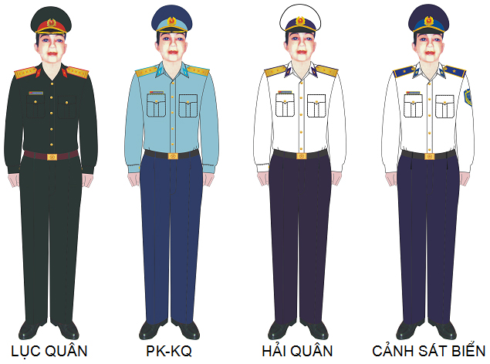
Army |  | Air Defend  Air Force |  | Navy |  | Coast Guard

2. Female officers, Warrant officer
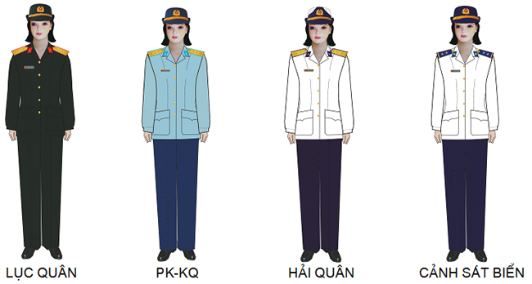
Army |  | Air Defend  Air Force |  | Navy |  | Coast Guard
Where to use: Worn in learning, working, living, working daily in the transitional period between the hot and cold seasons. When meetings and activities focused commander regulation wearing a military uniform consistency.

G. Number 7 - Warm uniforms

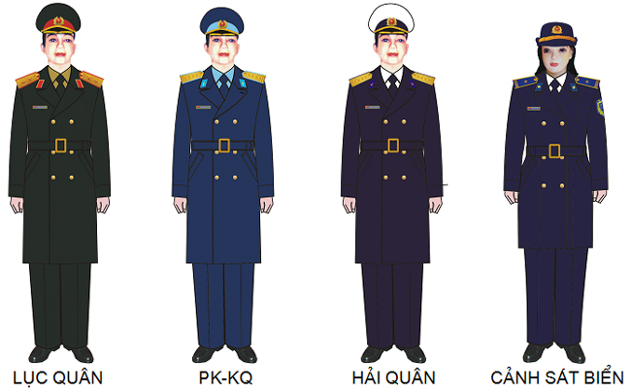
Male officers, Warrant officer
Army |  | Air Defend  Air Force |  | Navy |  | Coast Guard

Where to use: In cold weather days. When meetings and activities focused commander regulation wearing a military uniform consistency.

H. Number 8 – Combat uniform
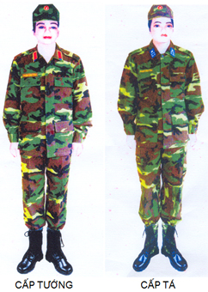
Where to use:
- In sports training outside school, rehearsal, practice marching, military seminars.
- In combat, combat service.
- During labor, in rescuing victims.
- To wear when visiting training, military exercises overseas.

APPENDIX 4: THE ENGLISH SOUNDS
1. Vowel sounds
/ɪ/  kid /kɪd/  village /ˈvɪlɪdʒ/ | /iː/  sea /siː/  green /ɡriːn/ | /ʊ/  good /ɡʊd/  put /pʊt/ | /uː/  goose /ɡuːs/  blue/bluː/
/e/  dress /dres/  bed /bed/ | /æ/  trap /træp/  bad /bæd/ | /ə/  banana /bəˈnɑːnə/ teacher /ˈtiːtʃər/ | /ɜː/  burn /bɜːn/  birthday /ˈbɜːθdeɪ/
/ɒ/  hot /hɒt/  box /bɒks/ | /ɔː/  ball /bɔːl/  law /lɔː/ | /ʌ/  come /kʌm/  love /lʌv/ | /ɑː/  start /stɑːt/  father /ˈfɑːðər/

/ɪə/  near /nɪər/  here /hɪər/ | /eɪ/  face /feɪs/  day /deɪ/ | /ʊə/  poor /pʊər/  jury /ˈdʒʊəri/ | /ɔɪ/  choice /tʃɔɪs/  boy /bɔɪ/
/əʊ/  goat /ɡəʊt/  show /ʃəʊ/ | /eə/  square /skweər/ fair /feər/ | /aɪ/  price /praɪs/  try /traɪ/ | /aʊ/  mouth/maʊθ/  cow /kaʊ/

2. Consonnant sounds

/p/  pen /pen/  copy /ˈkɒpi/ | /b/  back /bæk/  job /dʒɒb/ | /t/  tea /tiː/  tight /taɪt/ | /d/  day /deɪ/  ladder /ˈlædər/
/ʧ/  church /ʧɜːʧ/ match /mætʃ/ | /ʤ/  age /eiʤ/  gym /dʒɪm/ | /k/  key /ki:/  school /sku:l/ | /g/  get /ɡet/  ghost /ɡəʊst/
/f/  fat /fæt/  coffee /ˈkɒfi/ | /v/  view /vjuː/  move /muːv/ | /θ/  thin /θɪn/  path /pɑːθ/ | /ð/  this /ðɪs/  other /ˈʌðər/
/s/  soon /suːn/  sister /ˈsɪstər/ | /z/  zero /ˈzɪərəʊ/  buzz /bʌz/ | /ʃ/  ship /ʃɪp/  sure /ʃɔːr/ | /ʒ/  pleasure /’pleʒər/  vision /ˈvɪʒn/
/m/  more /mɔːr/  room /ruːm/ | /n/  nice /naɪs/  sun /sʌn/ | /ŋ/  ring /riŋ/  long /lɒŋ/ | /h/  hot /hɒt/  behind /bɪˈhaɪnd/
/l/  light /laɪt/  feel /fiːl/ | /r/  right /raɪt/  sorry /ˈsɒri/ | /w/  wet /wet/  win /wɪn/ | /j/  yes /jes/  use /ju:z/

APPENDIX 5: IRREGULAR VERB

No. | Verb | Past simple | Past perfect | Meaning
1 | abide | abode/abided | abode/abided | lưu trú, lưu lại
2 | arise | arose | arisen | phát sinh
3 | awake | awoke | awoken | đánh thức, thức
4 | backslide | backslid | backslidden/backslid | tái phạm
5 | be | was/were | been | thì, là, bị, ở
6 | bear | bore | borne | mang, chịu đựng
7 | beat | beat | beaten/beat | đánh, đập
8 | become | became | become | trở nên
9 | befall | befell | befallen | xảy đến
10 | begin | began | begun | bắt đầu
11 | behold | beheld | beheld | ngắm nhìn
12 | bend | bent | bent | bẻ cong
13 | beset | beset | beset | bao quanh
14 | bespeak | bespoke | bespoken | chứng tỏ
15 | bet | bet/betted | bet/betted | đánh cược, cá cược
16 | bid | bid | bid | trả giá
17 | bind | bound | bound | buộc, trói
18 | bite | bit | bitten | cắn
19 | bleed | bled | bled | chảy máu
20 | blow | blew | blown | thổi
21 | break | broke | broken | đập vỡ
22 | breed | bred | bred | nuôi, dạy dỗ
23 | bring | brought | brought | mang đến
24 | broadcast | broadcast | broadcast | phát thanh
25 | browbeat | browbeat | browbeaten/browbeat | hăm dọa
26 | build | built | built | xây dựng
27 | burn | burnt/burned | burnt/burned | đốt, cháy
28 | burst | burst | burst | nổ tung, vỡ òa
29 | bust | busted/bust | busted/bust | làm bể, làm vỡ
30 | buy | bought | bought | mua
31 | cast | cast | cast | ném, tung
32 | catch | caught | caught | bắt, chụp
33 | chide | chid/chided | chid/chidden/chided | mắng, chửi
34 | choose | chose | chosen | chọn, lựa
35 | cleave | clove/cleft/cleaved | cloven/cleft/cleaved | chẻ, tách hai
36 | cleave | clave | cleaved | dính chặt
37 | cling | clung | clung | bám vào, dính vào
38 | clothe | clothed/clad | clothed/clad | che phủ
39 | come | came | come | đến, đi đến
40 | cost | cost | cost | có giá là
41 | creep | crept | crept | bò, trườn, lẻn
42 | crossbreed | crossbred | crossbred | cho lai giống
43 | crow | crew/crewed | crowed | gáy (gà)
44 | cut | cut | cut | cắt, chặt
45 | daydream | daydreamed  daydreamt | daydreamed  daydreamt | nghĩ vẩn vơ, mơ mộng
46 | deal | dealt | dealt | giao thiệp
47 | dig | dug | dug | đào
48 | disprove | disproved | disproved/disproven | bác bỏ
49 | dive | dove/dived | dived | lặn, lao xuống
50 | do | did | done | làm
51 | draw | drew | drawn | vẽ, kéo
52 | dream | dreamt/dreamed | dreamt/dreamed | mơ thấy
53 | drink | drank | drunk | uống
54 | drive | drove | driven | lái xe
55 | dwell | dwelt | dwelt | trú ngụ, ở
56 | eat | ate | eaten | ăn
57 | fall | fell | fallen | ngã, rơi
58 | feed | fed | fed | cho ăn, ăn, nuôi
59 | feel | felt | felt | cảm thấy
60 | fight | fought | fought | chiến đấu
61 | find | found | found | tìm thấy, thấy
62 | fit | fitted/fit | fitted/fit | làm cho vừa, làm cho hợp
63 | flee | fled | fled | chạy trốn
64 | fling | flung | flung | tung, quăng
65 | fly | flew | flown | bay
66 | forbear | forbore | forborne | nhịn
67 | forbid | forbade/forbad | forbidden | cấm, cấm đoán
68 | forecast | forecast/forecasted | forecast/forecasted | tiên đoán
69 | forego (also forgo) | forewent | foregone | bỏ, kiêng
70 | foresee | foresaw | forseen | thấy trước
71 | foretell | foretold | foretold | đoán trước
72 | forget | forgot | forgotten | quên
73 | forgive | forgave | forgiven | tha thứ
74 | forsake | forsook | forsaken | ruồng bỏ
75 | freeze | froze | frozen | (làm) đông lại
76 | frostbite | frostbit | frostbitten | bỏng lạnh
77 | get | got | got/gotten | có được
78 | gild | gilt/gilded | gilt/gilded | mạ vàng
79 | gird | girt/girded | girt/girded | đeo vào
80 | give | gave | given | cho
81 | go | went | gone | đi
82 | grind | ground | ground | nghiền, xay
83 | grow | grew | grown | mọc, trồng
84 | hand-feed | hand-fed | hand-fed | cho ăn bằng tay
85 | handwrite | handwrote | handwritten | viết tay
86 | hang | hung | hung | móc lên, treo lên
87 | have | had | had | có
88 | hear | heard | heard | nghe
89 | heave | hove/heaved | hove/heaved | trục lên
90 | hew | hewed | hewn/hewed | chặt, đốn
91 | hide | hid | hidden | giấu, trốn, nấp
92 | hit | hit | hit | đụng
93 | hurt | hurt | hurt | làm đau
94 | inbreed | inbred | inbred | lai giống cận huyết
95 | inlay | inlaid | inlaid | cẩn, khảm
96 | input | input | input | đưa vào
97 | inset | inset | inset | dát, ghép
98 | interbreed | interbred | interbred | giao phối, lai giống
99 | interweave | interwove  interweaved | interwoven  interweaved | trộn lẫn, xen lẫn
100 | interwind | interwound | interwound | cuộn vào, quấn vào
101 | jerry-build | jerry-built | jerry-built | xây dựng cẩu thả
102 | keep | kept | kept | giữ
103 | kneel | knelt/kneeled | knelt/kneeled | quỳ
104 | knit | knit/knitted | knit/knitted | đan
105 | know | knew | known | biết, quen biết
106 | lay | laid | laid | đặt, để
107 | lead | led | led | dẫn dắt, lãnh đạo
108 | lean | leaned/leant | leaned/leant | dựa, tựa
109 | leap | leapt | leapt | nhảy, nhảy qua
110 | learn | learnt/learned | learnt/learned | học, được biết
111 | leave | left | left | ra đi, để lại
112 | lend | lent | lent | cho mượn
113 | let | let | let | cho phép, để cho
114 | lie | lay | lain | nằm
115 | light | lit/lighted | lit/lighted | thắp sáng
116 | lip-read | lip-read | lip-read | mấp máy môi
117 | lose | lost | lost | làm mất, mất
118 | make | made | made | chế tạo, sản xuất
119 | mean | meant | meant | có nghĩa là
120 | meet | met | met | gặp mặt
121 | miscast | miscast | miscast | chọn vai đóng không hợp
122 | misdeal | misdealt | misdealt | chia lộn bài, chia bài sai
123 | misdo | misdid | misdone | phạm lỗi
124 | mishear | misheard | misheard | nghe nhầm
125 | mislay | mislaid | mislaid | để lạc mất
126 | mislead | misled | misled | làm lạc đường
127 | mislearn | mislearned  mislearnt | mislearned  mislearnt | học nhầm
128 | misread | misread | misread | đọc sai
129 | misset | misset | misset | đặt sai chỗ
130 | misspeak | misspoke | misspoken | nói sai
131 | misspell | misspelt | misspelt | viết sai chính tả
132 | misspend | misspent | misspent | tiêu phí, bỏ phí
133 | mistake | mistook | mistaken | phạm lỗi, lầm lẫn
134 | misteach | mistaught | mistaught | dạy sai
135 | misunderstand | misunderstood | misunderstood | hiểu lầm
136 | miswrite | miswrote | miswritten | viết sai
137 | mow | mowed | mown/mowed | cắt cỏ
138 | offset | offset | offset | đền bù
139 | outbid | outbid | outbid | trả hơn giá
140 | outbreed | outbred | outbred | giao phối xa
141 | outdo | outdid | outdone | làm giỏi hơn
142 | outdraw | outdrew | outdrawn | rút súng ra nhanh hơn
143 | outdrink | outdrank | outdrunk | uống quá chén
144 | outdrive | outdrove | outdriven | lái nhanh hơn
145 | outfight | outfought | outfought | đánh giỏi hơn
146 | outfly | outflew | outflown | bay cao/xa hơn
147 | outgrow | outgrew | outgrown | lớn nhanh hơn
148 | outleap | outleaped/outleapt | outleaped/outleapt | nhảy cao/xa hơn
149 | outlie | outlied | outlied | nói dối
150 | output | output | output | cho ra (dữ kiện)
151 | outride | outrode | outridden | cưỡi ngựa giỏi hơn
152 | outrun | outran | outrun | chạy nhanh hơn, vượt giá
153 | outsell | outsold | outsold | bán nhanh hơn
154 | outshine | outshined/outshone | outshined/outshone | sáng hơn, rạng rỡ hơn
155 | outshoot | outshot | outshot | bắn giỏi hơn, nảy mầm, mọc
156 | outsing | outsang | outsung | hát hay hơn
157 | outsit | outsat | outsat | ngồi lâu hơn
158 | outsleep | outslept | outslept | ngủ lâu/muộn hơn
159 | outsmell | outsmelled/outsmelt | outsmelled/outsmelt | khám phá, đánh hơi, sặc mùi
160 | outspeak | outspoke | outspoken | nói nhiều/dài/to hơn
161 | outspeed | outsped | outsped | đi/chạy nhanh hơn
162 | outspend | outspent | outspent | tiêu tiền nhiều hơn
163 | outswear | outswore | outsworn | nguyền rủa nhiều hơn
164 | outswim | outswam | outswum | bơi giỏi hơn
165 | outthink | outthought | outthought | suy nghĩ nhanh hơn
166 | outthrow | outthrew | outthrown | ném nhanh hơn
167 | outwrite | outwrote | outwritten | viết nhanh hơn
168 | overbid | overbid | overbid | trả giá/bỏ thầu cao hơn
169 | overbreed | overbred | overbred | nuôi quá nhiều
170 | overbuild | overbuilt | overbuilt | xây quá nhiều
171 | overbuy | overbought | overbought | mua quá nhiều
172 | overcome | overcame | overcome | khắc phục
173 | overdo | overdid | overdone | dùng quá mức, làm quá
174 | overdraw | overdrew | overdrawn | rút quá số tiền, phóng đại
175 | overdrink | overdrank | overdrunk | uống quá nhiều
176 | overeat | overate | overeaten | ăn quá nhiều
177 | overfeed | overfed | overfed | cho ăn quá mức
178 | overfly | overflew | overflown | bay qua
179 | overhang | overhung | overhung | nhô lên trên, treo lơ lửng
180 | overhear | overheard | overheard | nghe trộm
181 | overlay | overlaid | overlaid | phủ lên
182 | overpay | overpaid | overpaid | trả quá tiền
183 | override | overrode | overridden | lạm quyền
184 | overrun | overran | overrun | tràn ngập
185 | oversee | oversaw | overseen | trông nom
186 | oversell | oversold | oversold | bán quá mức
187 | oversew | oversewed | oversewn/oversewed | may nối vắt
188 | overshoot | overshot | overshot | đi quá đích
189 | oversleep | overslept | overslept | ngủ quên
190 | overspeak | overspoke | overspoken | Nói quá nhiều, nói lấn át
191 | overspend | overspent | overspent | tiêu quá lố
192 | overspill | overspilled/overspilt | overspilled/overspilt | đổ, làm tràn
193 | overtake | overtook | overtaken | đuổi bắt kịp
194 | overthink | overthought | overthought | tính trước nhiều quá
195 | overthrow | overthrew | overthrown | lật đổ
196 | overwind | overwound | overwound | lên dây (đồng hồ) quá chặt
197 | overwrite | overwrote | overwritten | viết dài quá, viết đè lên
198 | partake | partook | partaken | tham gia, dự phần
199 | pay | paid | paid | trả (tiền)
200 | plead | pleaded/pled | pleaded/pled | bào chữa, biện hộ
201 | prebuild | prebuilt | prebuilt | làm nhà tiền chế
202 | predo | predid | predone | làm trước
203 | premake | premade | premade | làm trước
204 | prepay | prepaid | prepaid | trả trước
205 | presell | presold | presold | bán trước thời gian rao báo
206 | preset | preset | preset | thiết lập sẵn, cài đặt sẵn
207 | preshrink | preshrank | preshrunk | ngâm cho vải co trước khi may
208 | proofread | proofread | proofread | Đọc bản thảo trước khi in
209 | prove | proved | proven/proved | chứng minh
210 | put | put | put | đặt, để
211 | quick-freeze | quick-froze | quick-frozen | kết đông nhanh
212 | quit | quit/quitted | quit/quitted | bỏ
213 | read | read | read | đọc
214 | reawake | reawoke | reawaken | đánh thức 1 lần nữa
215 | rebid | rebid | rebid | trả giá, bỏ thầu
216 | rebind | rebound | rebound | buộc lại, đóng lại
217 | rebroadcast | rebroadcast  rebroadcasted | rebroadcast  rebroadcasted | cự tuyệt, khước từ
218 | rebuild | rebuilt | rebuilt | xây dựng lại
219 | recast | recast | recast | đúc lại
220 | recut | recut | recut | cắt lại, băm)
221 | redeal | redealt | redealt | phát bài lại
222 | redo | redid | redone | làm lại
223 | redraw | redrew | redrawn | kéo ngược lại
224 | refit | refitted/refit | refitted/refit | luồn, xỏ
225 | regrind | reground | reground | mài sắc lại
226 | regrow | regrew | regrown | trồng lại
227 | rehang | rehung | rehung | treo lại
228 | rehear | reheard | reheard | nghe trình bày lại
229 | reknit | reknitted/reknit | reknitted/reknit | đan lại
230 | relay | relaid | relaid | đặt lại
231 | relay | relayed | relayed | truyền âm lại
232 | relearn | relearned/relearnt | relearned/relearnt | học lại
233 | relight | relit/relighted | relit/relighted | thắp sáng lại
234 | remake | remade | remade | làm lại, chế tạo lại
235 | rend | rent | rent | toạc ra, xé
236 | repay | repaid | repaid | hoàn tiền lại
237 | reread | reread | reread | đọc lại
238 | rerun | reran | rerun | chiếu lại, phát lại
239 | resell | resold | resold | bán lại
240 | resend | resent | resent | gửi lại
241 | reset | reset | reset | đặt lại, lắp lại
242 | resew | resewed | resewn/resewed | may/khâu lại
243 | retake | retook | retaken | chiếm lại,tái chiếm
244 | reteach | retaught | retaught | dạy lại
245 | retear | retore | retorn | khóc lại
246 | retell | retold | retold | kể lại
247 | rethink | rethought | rethought | suy tính lại
248 | retread | retread | retread | lại giẫm/đạp lên
249 | retrofit | retrofitted/retrofit | retrofitted/retrofit | trang bị thêm những bộ phận mới
250 | rewake | rewoke/rewaked | rewaken/rewaked | đánh thức lại
251 | rewear | rewore | reworn | mặc lại
252 | reweave | rewove/reweaved | rewoven/reweaved | dệt lại
253 | rewed | rewed/rewedded | rewed/rewedded | kết hôn lại
254 | rewet | rewet/rewetted | rewet/rewetted | làm ướt lại
255 | rewin | rewon | rewon | thắng lại
256 | rewind | rewound | rewound | cuốn lại, lên dây lại
257 | rewrite | rewrote | rewritten | viết lại
258 | rid | rid | rid | giải thoát
259 | ride | rode | ridden | cưỡi
260 | ring | rang | rung | rung chuông
261 | rise | rose | risen | đứng dậy, mọc
262 | roughcast | roughcast | roughcast | tạo hình phỏng chừng
263 | run | ran | run | chạy
264 | sand-cast | sand-cast | sand-cast | đúc bằng khuôn cát
265 | saw | sawed | sawn | cưa
266 | say | said | said | nói
267 | see | saw | seen | nhìn thấy
268 | seek | sought | sought | tìm kiếm
269 | sell | sold | sold | bán
270 | send | sent | sent | gửi
271 | set | set | set | đặt, thiết lập
272 | sew | sewed | sewn/sewed | may
273 | shake | shook | shaken | lay, lắc
274 | shave | shaved | shaved/shaven | cạo (râu, mặt)
275 | shear | sheared | shorn | xén lông (cừu)
276 | shed | shed | shed | rơi, rụng
277 | shine | shone | shone | chiếu sáng
278 | shit | shit/shat/shitted | shit/shat/shitted | suộc khuộng đi đại tiện
279 | shoot | shot | shot | bắn
280 | show | showed | shown/showed | cho xem
281 | shrink | shrank | shrunk | co rút
282 | shut | shut | shut | đóng lại
283 | sight-read | sight-read | sight-read | chơi hoặc hát mà không cần nghiên cứu trước
284 | sing | sang | sung | ca hát
285 | sink | sank | sunk | chìm, lặn
286 | sit | sat | sat | ngồi
287 | slay | slew | slain | sát hại, giết hại
288 | sleep | slept | slept | ngủ
289 | slide | slid | slid | trượt, lướt
290 | sling | slung | slung | ném mạnh
291 | slink | slunk | slunk | lẻn đi
292 | slit | slit | slit | rạch, khứa
293 | smell | smelt | smelt | ngửi
294 | smite | smote | smitten | đập mạnh
295 | sneak | sneaked/snuck | sneaked/snuck | trốn, lén
296 | speak | spoke | spoken | nói
298 | speed | sped/speeded | sped/speeded | chạy vụt
299 | spell | spelt/spelled | spelt/spelled | đánh vần
300 | spend | spent | spent | tiêu xài
301 | spill | spilt/spilled | spilt/spilled | tràn, đổ ra
302 | spin | spun/span | spun | quay sợi
303 | spoil | spoilt/spoiled | spoilt/spoiled | làm hỏng
304 | spread | spread | spread | lan truyền
305 | stand | stood | stood | đứng
305 | steal | stole | stolen | đánh cắp
306 | stick | stuck | stuck | ghim vào, đính
307 | sting | stung | stung | châm, chích, đốt
308 | stink | stunk/stank | stunk | bốc mùi hôi
309 | stride | strode | stridden | bước sải
310 | strike | struck | struck | đánh đập
311 | string | strung | strung | gắn dây vào
312 | sunburn | sunburned/sunburnt | sunburned/sunburnt | cháy nắng
313 | swear | swore | sworn | tuyên thệ
314 | sweat | sweat/sweated | sweat/sweated | đổ mồ hôi
315 | sweep | swept | swept | quét
316 | swell | swelled | swollen/swelled | phồng, sưng
317 | swim | swam | swum | bơi lội
318 | swing | swung | swung | đong đưa
319 | take | took | taken | cầm, lấy
320 | teach | taught | taught | dạy, giảng dạy
321 | tear | tore | torn | xé, rách
322 | telecast | telecast | telecast | phát đi bằng truyền hình
323 | tell | told | told | kể, bảo
324 | think | thought | thought | suy nghĩ
325 | throw | threw | thrown | ném,, liệng
326 | thrust | thrust | thrust | thọc, nhấn
327 | tread | trod | trodden/trod | giẫm, đạp
328 | typewrite | typewrote | typewritten | đánh máy
329 | unbend | unbent | unbent | làm thẳng lại
330 | unbind | unbound | unbound | mở, tháo ra
331 | unclothe | unclothed/unclad | unclothed/unclad | cởi áo, lột trần
332 | undercut | undercut | undercut | ra giá rẻ hơn
333 | underfeed | underfed | underfed | cho ăn đói, thiếu ăn
334 | undergo | underwent | undergone | kinh qua
335 | underlie | underlay | underlain | nằm dưới
336 | understand | understood | understood | hiểu
337 | undertake | undertook | undertaken | đảm nhận
338 | underwrite | underwrote | underwritten | bảo hiểm
339 | undo | undid | undone | tháo ra
340 | unfreeze | unfroze | unfrozen | làm tan đông
341 | unhang | unhung | unhung | hạ xuống, bỏ xuống
342 | unhide | unhid | unhidden | hiển thị, không ẩn
343 | unlearn | unlearned/unlearnt | unlearned/unlearnt | gạt bỏ, quên
344 | unspin | unspun | unspun | quay ngược
345 | unwind | unwound | unwound | tháo ra
346 | uphold | upheld | upheld | ủng hộ
347 | upset | upset | upset | đánh đổ, lật đổ
348 | wake | woke/waked | woken/waked | thức giấc
349 | wear | wore | worn | mặc
350 | wed | wed/wedded | wed/wedded | kết hôn
351 | weep | wept | wept | khóc
352 | wet | wet/wetted | wet/wetted | làm ướt
353 | win | won | won | thắng, chiến thắng
354 | wind | wound | wound | quấn
355 | withdraw | withdrew | withdrawn | rút lui
356 | withhold | withheld | withheld | từ khước
357 | withstand | withstood | withstood | cầm cự
358 | work | worked | worked | rèn, nhào nặn đất
359 | wring | wrung | wrung | vặn, siết chặt
360 | write | wrote | written | viết

APPENDIX 6: LESSON’S VOCABULARY

 | Vocabualary | Pronounciation | Type | Meaning
A
1 | abide | /əˈbaɪd/ | v | chấp hành
2 | activity | /ækˈtɪv.ə.t̬i/ | n | hoạt động
3 | adhere | /ədˈhɪə/ | v | gắn kết
4 | administrative | /ædˈmɪn.ɪˌstreɪ.t̬ɪv/ | a | hành chính
5 | administrative | /ədˈmɪnɪstrətɪv/ | a | hành chính
6 | administrative | /ədˈmɪnɪstrətɪv/ | a | hành chính
7 | advise | /ədˈvaɪz/ | v | tham mưu
8 | aeronautical | /erəˈnɔːtɪkl/ | a | thuộc về hàng không
9 | aesthetics | /iːsˈθetɪk/ | n | thẩm mỹ
10 | amry corp | /ˈɑːmi kɔːp/ | n | Quân đoàn
11 | armed force | /ɑːm fɔːs/ | n | lực lượng vũ trang
12 | armed robbery | /ɑːm ˈrɒbəri/ | n | cướp có vũ trang
13 | arms trafficking | /ɑːm ˈtræfɪkɪŋ/ | n | buôn bán vũ khí
14 | arrest | /əˈrest/ | v | bắt giữ
15 | attainable | /əˈteɪnəbᵊl/ | a | có thể đạt tới
16 | autopilot | /ˈɔːtəʊpaɪlət/ | n | máy lái tự động
B
17 | bilateral | /ˌbaɪˈlætərəl/ | a | song phương
18 | Border Guard | /ˈbɔːdə ɡɑːd/ | n | Bộ đội biên phòng
19 | breadth | /bredθ/ | n | chiều rộng
C
20 | case | /keɪs/ | n | báo vụ
21 | ceremonial | /ˌserɪˈməʊniəl/ | a | lễ hội
22 | channel | /ˈtʃænl/ | n | luồng thủy
23 | charter | /ˈtʃɑːtə(r)/ | n | hiến chương
24 | civil | /ˈsɪvl/ | a | dân sự
25 | coast guard regional command | /kəʊst ɡɑːd ˈriːdʒənl kəˈmɑːnd/ | n | BTL vùng cảnh sát biển
26 | coast guard ship | /kəʊst ɡɑːd ʃɪp/ | n | tàu cảnh sát biển
27 | code | /kəʊd/ | n | bộ luật
28 | combat | /ˈkɒmbæt/ | n | huấn luyện, dã ngoại
29 | combat unit | /ˈkɒmbæt ˈjuːnɪt/ | n | đơn vị chiến đấu
30 | command | /kəˈmɑːnd/ | n | điều lệnh
31 | commandant | /ˈkɒm.ən.dænt/ | n | tư lệnh
32 | commander | /kəˈmɑːndə(r)/ | n | người chỉ huy
33 | commanding officer | /kəˈmɑːndiŋ ˈɒfɪsə(r)/ | n | sỹ quan chỉ huy
34 | commercial fraud | /kəˈmɜːʃl frɔːd/ | n | gian lận thương mại
35 | communications | /kəˌmjuːnɪˈkeɪʃn/ | n | thông tin liên lạc
36 | communist party of vietnam | /ˈkɒmjənɪst ˈpɑːti əv / | n | đảng cộng sản việt nam
37 | company | /ˈkʌmpəni/ | n | đại đội
38 | compass | /ˈkʌmpəs/ | n | la bàn
39 | compatibility | /kəmˌpætəˈbɪləti/ | n | tính tương thích
40 | competence | /ˈkɒmpɪtəns/ | n | thẩm quyền
41 | competently | /ˈkɑːmpɪtəntli/ | adv | thành thạo, điêu luyện
42 | comprehensive partnership | /ˌkɒmprɪˈhɛnsɪv ˈpɑːtnəʃɪp/ | n | đối tác toàn diện
43 | computations | /ˌkɒmpjəˈteɪʃᵊnz/ | n | sự ước tính
44 | conduct | /ˈkɒndʌkt/ | v | tiến hành
45 | confidential | /ˌkɒnfɪˈdenʃl/ | a | bí mật
46 | conformity | /kənˈfɔːməti / | a | phù hợp
47 | consensus | /kənˈsen.səs/ | n | sự đồng ý
48 | consistency | /kənˈsɪstənsi/ | n | tính thống nhất
49 | constitution | /ˌkɒnstɪˈtjuːʃn/ | n | hiến pháp
50 | continental shelf geography | /ˌkɒntɪˈnentl ʃelf dʒiˈɒɡrəfi/ | n | thềm lục địa
51 | control | /kənˈtroʊl/ | v | kiểm soát
52 | convention | /kənˈvenʃn/ | n | công ước
53 | coordin ation | /koʊˌɔːr.dənˈeɪ.ʃən/ | n | sự phối hợp
54 | cope | /kəʊp/ | v | đối mặt với
55 | core | /kɔː(r)/ | n | nòng cốt
56 | corps | /kɔː(r)/ | n | quân đoàn
57 | corridor | /ˈkɒrɪdɔː(r)/ | n | hành lang
58 | counter-attacking | /ˈkaʊntər əˈtækiŋ/ | a | phản công
59 | counterpart | /ˈkaʊn.t̬ɚ.pɑːrt/ | n | đối tác
60 | criminal | /ˈkrɪm.ə.nəl/ | n | tội phạm
61 | criminal investigation agency | /ˈkrɪmɪnl ɪnˌvestɪˈɡeɪʃn ˈeɪdʒənsi/ | n | cơ quan điều tra hình sự
62 | criminal procedure | /ˈkrɪmɪnl prəˈsiːdʒə(r)/ | n | tố tụng hình sự
63 | customs | /ˈkʌstəmz/ | n | hải quan
64 | cutter | /ˈkʌtə/ | n | tàu tuần duyên
65 | Cyber Command | /ˈsaɪbə kəˈmɑːnd / | n | Bộ Tư lệnh Tác chiến không gian mạng
66 | cyberspace | /ˈsaɪbəˌspeɪs/ | n | không gian mạng
D
67 | datum point | /ˈdeɪtəm pɔɪnt/ | n | điểm bắt đầu trôi
68 | dead reckoning | /dɛd ˈrɛkənɪŋ/ | n | điểm chết
69 | decentralization | /ˌdiːˌsentrəlaɪˈzeɪʃn/ | n | phân cấp
70 | decision | /dɪˈsɪʒ.ən/ | n | quyết định
71 | decree | /dɪˈkriː/ | n | nghị định
72 | defense minister | /dɪˈfens ˈmɪnɪstə(r)/ | n | bộ trưởng bộ quốc phòng
73 | defensive | /dɪˈfensɪv/ | a | phòng ngự
74 | depth gauge | /depθ ɡeɪdʒ/ | n | máy đo sâu
75 | designation | /ˌdezɪɡˈneɪʃn/ | n | sự chỉ định
76 | detect | /dɪˈtekt/ | n | phát hiện
77 | determine | /dɪˈtɜːmɪn/ | v | xác định, quyết định
78 | diplomacy | /dɪˈpləʊməsi/ | n | ngoại giao
79 | diplomatic policies | /ˌdɪpləˈmætɪk ˈpɒləsiz/ | n | chính sách ngoại giao
80 | discipline | /ˈdɪsəplɪn/ | n | kỷ luật
81 | displacement | /dɪsˈpleɪsmənt/ | n | lượng giãn nước
82 | dispute | /dɪˈspjuːt/ | n | tranh chấp
83 | division | /dɪˈvɪʒn/ | n | sư đoàn
84 | domination | /ˌdɒmɪˈneɪʃn/ | n | sự thống lĩnh
85 | drift | /drɪft./ | n | sự trôi dạt
86 | duty | /ˈduː.t̬i/ | n | nhiệm vụ
E
87 | economic-defence unit | /ˌiːkəˈnɒmɪk-dɪˈfɛns ˈjuːnɪts/ | n | đơn vị kinh tế quốc phòng
88 | electricity and engine | /ɪˌlekˈtrɪsəti ənd ˈendʒɪn/ | n | cơ điện
89 | electronic chart | /ɪˌlekˈtrɒnɪk tʃɑːt/ | n | hải đồ điện tử
90 | electronic warfare | /ɪˌlekˈtrɒnɪk ˈwɔːfeə(r)/ | n | chiến tranh điện tử
91 | elegance | /ˈelɪɡəns/ | n | sang trọng
92 | eliminate | /ɪˈlɪmɪneɪt/ | v | loại trừ
93 | enforcement | /ɪnˈfɔːsmənt/ | n | thực thi
94 | engineer | /ˌendʒɪˈnɪə(r)/ | n | công binh
95 | geographical | /ʤɪəˈɡræfɪkəl/ | a | thuộc về địa lý
96 | epidemic | /ˌepɪˈdemɪk/ | n | dịch bệnh
97 | estimate | /ˈes.tɪ.meɪt/ |  | sự đánh giá, uớc lượng
98 | estuary | /ˈestʃuəri/ | n | cửa sông
99 | etiquette | /ˈetɪkət/ | n | nghi lễ, nghi thức
100 | evacuation | /ɪˌvækjuˈeɪʃn/ | n | di tản
101 | executive officer | /ɪɡˈzekjətɪv ˈɒfɪsə(r)/ | n | phó thuyền trưởng
102 | exploit | /ɪkˈsplɔɪt/ | v | khai thác
103 | explosives | /ɪkˈspləʊsɪv/ | n | vật liệu nổ
F
103 | fire | /ˈfaɪə(r)/ | n | hỏa lực
104 | fisheries law | /ˈfɪʃəri lɔː/ | n | luật thủy sản
105 | fixed drilling rig | /fɪkst drɪlliŋ rɪɡ/ | n | giàn khoan cố định
106 | flight assurance crew | /flaɪt əˈʃʊərəns kruː/ | n | kíp đảm bảo bay
107 | floating facilities | /ˈfləʊtɪŋ fəˈsɪləti/ | n | phương tiện nổi
108 | foreign relations | /ˈfɒrən rɪˈleɪʃᵊnz/ | n | quan hệ đối ngoại
109 | formation | /fɔːˈmeɪʃn/ | n | hình thành
110 | function | /ˈfʌŋkʃn/ | n | chức năng
G
111 | global positioning | /ˈɡləʊbl pəˈzɪʃənɪŋ/ | n | hệ thống định vị toàn cầu
112 | grasp | /ɡrɑːsp/ | v | nắm bắt
113 | grassroot | /ˌɡrɑːsˈruːts/ | n | cấp cơ sở
114 | guidelines | /ˈɡaɪdlaɪn/ | n | chủ trương
115 | gyro compass | /ˈdʒaɪrəʊ ˈkʌmpəs/ | n | la bàn con quay
H
116 | hand flags | /hænd flæɡ/ | n | cờ tay
117 | hardship | /ˈhɑːdʃɪp/ | n | khó khăn
118 | headquarter | /ˌhedˈkwɔːtəz/ | n | sở chỉ huy
119 | homesickness | /ˈhəʊmsɪknəs/ | n | nhớ nhà
120 | humanitarian | /hjuːˌmænɪˈteriən/ | a, n | nhân đạo
121 | humanitarian assistance | /hjuːˌmænɪˈteəriən əˈsɪstəns/ | n | hỗ trợ nhân đạo
I
122 | ICAO (The International Civil Aviation Organization) |  | n | tổ chức hàng không dân dụng quốc tế
123 | IMO (The International Maritime Organization) |  | n | tổ chức hàng hải quốc tế
124 | implement | /ˈɪm.plə.ment/ | v | triển khai
125 | implement | /ˈɪmplɪment/ | v | công cụ, phương tiện
126 | in accordance with | /ɪn əˈkɔːdns wɪð/ | prep | đồng bộ
127 | industrialisation | /ɪnˌdʌstrɪəlaɪˈzeɪʃᵊn / | n | công nghiệp hóa
128 | incident | /ˈɪnsɪdənt/ | n | sự cố
129 | inevitable | /ɪnˈevɪtəbl/ | a | tất yếu
130 | initial | /ɪˈnɪʃəl/ | a | tính ban đầu
131 | initial information verification | /ɪˈnɪʃəl ˌɪnfəˈmeɪʃᵊn ˌvɛrɪfɪˈkeɪʃᵊn / | n | xác minh tin ban đầu
132 | initial position error | /ɪˈnɪʃəl pəˈzɪʃᵊn ˈɛrə/ | n | sai số vị trí ban đầu
133 | inline reconnaissance | /ˈɪn.laɪn rɪˈkɒnɪsəns / | n | trinh sát nội tuyến
134 | inspection | /ɪnˈspekʃn/ | n | kiểm tra
135 | integral | /ˈɪntɪɡrəl/ | a | tính thiết thực, cần thiết
136 | integrated marine | /ˈɪntɪɡreɪtɪd məˈriːn/ | n | hệ thống tích hợp hàng hải
137 | intercept | /ˌɪntəˈsept/ | v | ngăn chặn
138 | interest | /ˈɪntrəst/ | n | lợi ích
139 | international cooperation | /ˌɪntəˈnæʃᵊnᵊl kəʊˌɒpəˈreɪʃᵊn/ | n | hợp tác quốc tế
140 | investigation | /ɪnˌves.təˈɡeɪ.ʃən/ | n | điều tra
141 | invoke | /ɪnˈvəʊk/ | v | viện dẫn
142 | issue | /ˈɪʃ.uː/ | n | vấn đề
143 | itinerary magnetic | /aɪˈtɪnərəri mæɡˈnetɪk/ | n | hành trình
J
144 | joint patrols | /ʤɔɪnt pəˈtrəʊlz/ |  | tuần tra chung
145 | jurisdiction | /ˌdʒʊərɪsˈdɪkʃn/ | n | quyền tài phán
L
146 | last known position | /lɑːst nəʊn pəˈzɪʃᵊn/ | n | vị trí biết lần cuối
147 | law enforcement | /lɔː ɪnˈfɔːsmənt/ | n | thực thi pháp luật
148 | leeway | /ˈliːweɪ/ | n | sự trôi dạt
149 | leeway divergence | /ˈliːweɪ daɪˈvɜːʤəns/ |  | độ trễ của sự trôi dạt
150 | legislation | /ˌledʒɪsˈleɪʃn/ | n | nhiệm vụ
151 | legislative | /ˈledʒɪslətɪv/ | n | lập pháp
152 | legitimacy | /lɪˈdʒɪtɪməsi/ | n | tính chính danh
153 | legitimate | /lɪˈdʒɪtɪmət/ | n | hợp pháp
154 | local force | /ˈləʊkəl fɔːs/ | n | Bộ đội địa phương
155 | location | /ləʊˈkeɪʃn/ | n | vị trí
156 | long - range | /lɒŋ reɪndʒ/ | n | tầm xa
M
157 | main force | /meɪn fɔːs / | n | Bộ đội chủ lực
158 | marine economic | /məˈriːn /ˌiːkəˈnɒmɪk/ | n | kinh tế biển
159 | maritime delimitation | /ˈmærɪtaɪm diːˌlɪmɪˈteɪʃn/ | n | phân định biển
160 | maritime law enforcement | /ˈmærɪtaɪm lɔː ɪnˈfɔːsmənt/ |  | thực thi pháp luật trên biển
161 | mass mobilization | /mæs ˌməʊbɪlaɪˈzeɪʃᵊn/ | n | vận động quần chúng
162 | measures | /ˈmeʒ.ɚ/ | n | mức độ
163 | military medical crew | /ˈmɪlətri ˈmedɪkl kruː/ | n | kíp quân y
164 | military region | ˈmɪlətri ˈriːdʒən/ | n | quân khu
165 | mission | /ˈmɪʃn/ | n | nhiệm vụ
166 | modernisation | /ˌmɒdᵊnaɪˈzeɪʃᵊn / | n | Hiện đại hóa
167 | modernity | /məˈdɜːnəti/ | n | hiện đại
168 | modify | /ˈmɑːdɪfaɪ/ | v | làm bớt, làm thay đổi
169 | movement | /ˈmuːvmənt/ | n | cơ động
170 | multilateral | /ˌmʌltiˈlætərəl/ | adj | đa phương
171 | multilateral forums | /ˌmʌltɪˈlætərəl ˈfɔːrəmz/ |  | diễn đàn đa phương
172 | munitions | /mjuːˈnɪʃnz/ | n | đạn dược
173 | mutual understanding | /ˈmjuːʧuəl ˌʌndəˈstændɪŋ/ | n | sự thấu hiểu lẫn nhau
N
174 | narcotics prevention base | /nɑːˈkɒtɪk prɪˈvenʃn beɪs/ | n | đoàn đặc nhiệm pctp ma túy
175 | natural disasters | /ˈnætʃrəl dɪˈzɑːstə(r)/ | n | thiên tai
176 | navigation | /ˌnævɪˈɡeɪʃn/ | n | hàng hải
177 | Navy and Air defense - Air force | /ˈneɪvi ænd eər dɪˈfens - eər fɔːs/ | n | quân chủng hải quân và phòng quân- không quân
178 | norm | /nɔːm/ | n | chuẩn mực
O
179 | object | /ˈɒbʤɪkt/ | n | đối tượng
180 | observance | /əbˈzɜːvəns/ | n | việc chấp hành
181 | obstacle | /ˈɒbstəkl/ | n | chướng ngại vật
182 | obtain | /əbˈteɪn/ | v | thu thập
183 | offensive | /əˈfensɪv/ | a | tấn công
184 | officer | /ˈɒfɪsə(r)/ | n | sỹ quan
185 | offline reconnaissance | /ˌɒfˈlaɪn rɪˈkɒnɪsəns / | n | trinh sát ngoại tuyến
186 | on-scene coordinator (osc) | /ɒn-siːn kəʊˈɔːdɪneɪtə/ | n | điều phối viên hiện trường
187 | on-scene endurance | /ɒn-siːn ɪnˈdjʊərᵊns/ |  | điều phối viên hiện trường (duy trì cứu nạn)
188 | optimal | /ˈɒptɪməl/ | a | tối ưu
P
189 | patrol | /pəˈtrəʊl/ | v | tuần tra
190 | patrolling | /pəˈtrəʊllɪŋ/ | n | cuộc tuần tra
191 | peaceful evolution | /ˈpiːsfʊl ˌiːvəˈluːʃᵊn/ | n | “diễn biến hòa bình”
192 | Peacekeeping Department | /ˈpiːsˌkiːpɪŋ dɪˈpɑːtmənt / | n | Cục Gìn giữ hòa bình
193 | perform | /pɚˈfɔːrm/ | v | thực hiện
194 | piracy | /ˈpaɪrəsi/ | n | cướp biển
195 | plain clothes | /pleɪn kləʊðz/ | n | thường phục
196 | platoon | /pləˈtuːn/ | n | trung đội
197 | political commissar | /pəˈlɪtɪkl ˌkɒmɪˈsɑː(r)/ | n | chính trị viên
198 | posture | /ˈpɒstʃə(r)/ | n | tư thế
199 | potential | /pəˈtenʃl/ | a | tiềm tàng, tiềm năng
200 | power | /ˈpaʊə(r)/ | n | hùng mạnh
201 | predecessor | /ˈpriːdəsesə(r)/ | n | tiền thân
202 | principle | /ˈprɪnsəpl/ | n | nguyên tắc
203 | procedure | /prəˈsiː.dʒɚ/ | n | thủ tục
204 | professionalism | /prəˈfɛʃᵊnᵊlɪzᵊm/ | n | nghiệp vụ
205 | professionalism | /prəˈfɛʃᵊnᵊlɪzᵊm/ | n | sự chuyên nghiệp
206 | promptly | /ˈprɑːmpt.li/ | adv | nhanh chóng
207 | promulgate | /ˈprɒmlɡeɪt/ | v | ban hành
208 | propaganda | /ˌprɒpəˈɡændə/ | n | tuyên truyền
209 | property | /ˈprɒpəti/ | n | tài sản
210 | prosperity | /prɒsˈpɛrəti/ | n | thịnh vượng
211 | provision | /prəˈvɪʒn/ | n | quy định
212 | pursue | /pəˈsjuː/ | v | hướng tới
Q
213 | quality | /ˈkwɒləti/ | n | phẩm chất
R
214 | reconnaissance base | /rɪˈkɒnɪsns beɪs/ | n | đoàn trinh sát
215 | record keeping | /ˈrɛkɔːd ˈkiːpɪŋ / | n | hồ sơ lưu trữ
216 | regime | /reɪˈʒiːm/ | n | chế độ
217 | regiment | /ˈredʒɪmənt/ | n | trung đoàn
218 | regular | /ˈreɡjələ(r)/ | a | chính quy
219 | regularity | /ˌreɡjuˈlærəti/ | n | nền nếp chính quy
220 | regulation | /ˌreɡjuˈleɪʃn/ | n | quy định
221 | remediation | /rɪˌmiːdiˈeɪʃn/ | n | khắc phục
222 | report | /rɪˈpɔːrt/ | v | báo cáo
223 | rescue | /ˈreskjuː/ | n | cứu nạn
224 | research institute | /rɪˈsɜːʧ ˈɪnstɪtjuːts/ | n | Viện nghiên cứu
225 | reserve | /rɪˈzɜːv/ | n | lực lượng dự bị động viên
226 | resolutely | /ˈrezəluːtli/ | adv | kiên quyết
227 | revolutionary | /ˌrevəˈluːʃənəri/ | a | cách mạng
228 | righteousness | /ˈraɪtʃəsnəs/ | n | nhân chính
229 | road calculator | /rəʊd ˈkælkjuleɪtə(r)/ | n | máy tính đường
S
230 | safeguarding | /ˈseɪfɡɑːdɪŋ / | n | Sự bảo vệ
231 | SAR (search and rescue) | /sɜːrtʃ ənd ˈreskjuː/ | n | tìm kiếm và cứu nạn
232 | SAR facility | /ɛs-eɪ-ɑː fəˈsɪləti/ | n | cơ sở tìm kiếm và cứu nạn
233 | seafaring | /ˈsiːfeərɪŋ/ | n | đi biển
234 | seal | /siːl/ | n | con dấu
235 | search pattern | /sɜːʧ ˈpætən/ | n | mẫu tìm kiếm
236 | searching and collecting | /ˈsɜːʧɪŋ ænd kəˈlɛktɪŋ / | n | tìm kiếm và thu thập
237 | secret forces | /ˈsiːkrɪt ˈfɔːsɪz / | n | lực lượng mật
238 | section | /ˈsekʃn/ | n | tiểu đội
239 | service | /ˈsɜːvɪs/ | n | nghiệp vụ
240 | services | /ˈsɜːvɪsiz/ | n | quân, binh chủng
241 | settle | /ˈsetl/ | v | giải quyết
242 | smuggling | /ˈsmʌɡlɪŋ/ | n | buôn lậu
243 | sovereignty | /ˈsɒvrənti/ | n | chủ quyền
244 | special force | /ˈspeʃl fɔːs/ | n | đặc công
245 | specialised | /ˈspeʃəlaɪz/ | a | chuyên trách
246 | specialized combat | /ˈspɛʃəlaɪzd ˈkɒmbæt / | n | đấu tranh chuyên án
247 | specialized force | /ˈspeʃəlaɪz fɔːs/ | n | lực lượng chuyên trách
248 | specialized ships | /ˈspeʃəlaɪz ʃɪp/ | n | tàu chuyên dụng
249 | specific | /spəˈsɪfɪk/ | a | đặc thù
250 | SRR (search and rescue regions) | /sɜːrtʃ ənd ˈreskjuː ˈriːdʒən/ | n | khu vực tìm kiếm và cứu nạn
251 | staffing organization | /ˈstɑːfɪŋ ˌɔːɡənaɪˈzeɪʃn/ | n | tổ chức biên chế
252 | stationed | /ˈsteɪʃᵊnd/ | v | thực thi nhiệm vụ
253 | stipulate | /ˈstɪpjuleɪt/ | v | quy định
254 | strengthen | /ˈstrɛŋθən/ | v | làm sâu sắc thêm
255 | striking | /ˈstraɪkɪŋ/ | a | đột kích
256 | supervision | /ˌsuːpəˈvɪʒn/ | n | giám sát
257 | suspicious verification | /səsˈpɪʃəs ˌvɛrɪfɪˈkeɪʃᵊn / | n | xác minh hiềm nghi
258 | sweep width | /swiːp wɪdθ/ | n | chiều rộng quét
259 | synchronous | /ˈsɪŋkrənəs/ | a | đồng bộ
260 | synergize | /ˈsɪnədʒi/ | n | hiệp đồng
T
261 | technical logistics | /ˈteknɪkl ləˈdʒɪstɪks/ | n | hậu cần kỹ thuật
262 | terrain | /təˈreɪn/ | n | địa hình
263 | terrorism | /ˈterərɪzəm/ | n | khủng bố
264 | the general staff | /ðə ˈdʒenrəl stɑːf/ | n | bộ tổng tham mưu
265 | the waters | /ðə ˈwɔːtə(r)/ | n | vùng biển
266 | thoroughly | /ˈθɜːrəli/ | adv | hoàn toàn, thấy đáo
267 | timely | /ˈtaɪmli/ | a | kịp thời
268 | tracing | /ˈtreɪsɪŋ/ | n | truy xét, truy tìm
269 | track spacing | /træk ˈspeɪsɪŋ / | n | theo dõi khoảng cách
270 | transnational | /ˌtrænzˈnæʃnəl/ | a | xuyên quốc gia
271 | transparent | /trænsˈpærənt/ | a | thông suốt
272 | treaty | /ˈtriːti/ | n | điều ước
U
273 | unification | /ˌjuːnɪfɪˈkeɪʃn/ | n | sự thống nhất
274 | unite | /juˈnaɪt/ | a | đoàn kết
275 | unscheduled | /ʌnˈʃedjuːld/ | a | đột xuất
276 | usual | /ˈjuːʒuəl/ | a | thường dùng
V
277 | verify | /ˈver.ə.faɪ/ | v | xác minh
278 | vessel | /ˈves.əl/ | v | tàu, thuyền
279 | Vietnam Coast Guard High Command | /kəʊst ɡɑːd kəˈmɑːnd/ | n | BTL Cảnh sát biển  Việt Nam
280 | violation | /ˌvaɪəˈleɪʃn/ | n | vi phạm
281 | visibility | /ˌvɪzəˈbɪləti/ | n | tầm nhìn
W
282 | warrant officer | /ˈwɒr.ənt ˌɒf.ɪ.sər/ | n | quân nhân chuyên nghiệp
283 | watchstanding | /wɒʧˈstændɪŋ/ | n | canh gác
284 | working style | /ˈwɜːkɪŋ staɪl/ | n | tác phong

REFERENCE

1. Tiếng Anh quân sự, Nguyen Ngoc Bao, The People’s Army Publishing House, Hanoi - 2011.
2. Tiếng Anh quân sự chuyên ngành Pháo binh, Luong Thuy Hang, The College of Artillery officers training, 2014.
3. Giáo trình Tiếng Anh, Nguyen Duc Hau, The People’s Army Publishing House, Hanoi-2016.
4. Từ điển Anh-Việt Quân sự (2006), Nhà xuất bản Quân đội Nhân dân.
5. Từ điển bách khoa Công an nhân dân(2000), Nhà xuất bản Công an nhân dân.
6. Từ điển Cảnh sát biển Anh-Nga-Việt (2020), Nhà xuất bản Quân đội nhân dân.
7. Từ điển Kỹ thuật tổng hợp (1991), Nhà xuất bản Khoa học Kỹ thuật.
8. Campaign English for Military, Clark S.Miller & Y vonne Baker de Altamirano, Macmillan Publisher Limited, UK- 008.
9. Canadian Coast Guard, SAR SEMANDSHIP REFERENCE MANUAL, 2000.
10. Law on the Vietnam Coast Guard, Vietnam Coast Guard High Command, The People’s Army Publishing House, Hanoi – 2022.
11. Longman English Grammar, Alexander, Longman, UK -1995.
12. Luật số 32/2005/QĐ-BQP ngày 25/3/2005 của Bộ trưởng BQP về việc quy định sử dụng quân phục của Quân đội nhân dân VN.
13. New English file, Clive Oxenden & Christina Latham-Koeing, Oxford University Press, UK-2013.
14. Vietnam National Defense, National Political Publishing House, VN- 2019.
15. Oxford Student’s Dictionary of English, Oxford University Press, UK - 2005.
Personnel Recovery, Walter L. Sharp- Lieutenant General, USA-2007.
16. https://canhsatbien.vn/
17. https://www.colinsdictionary.com/dictionary/english
18. https://en.oxforddictionary.com/
19. https://www.merriam-webster.com/dictionary

